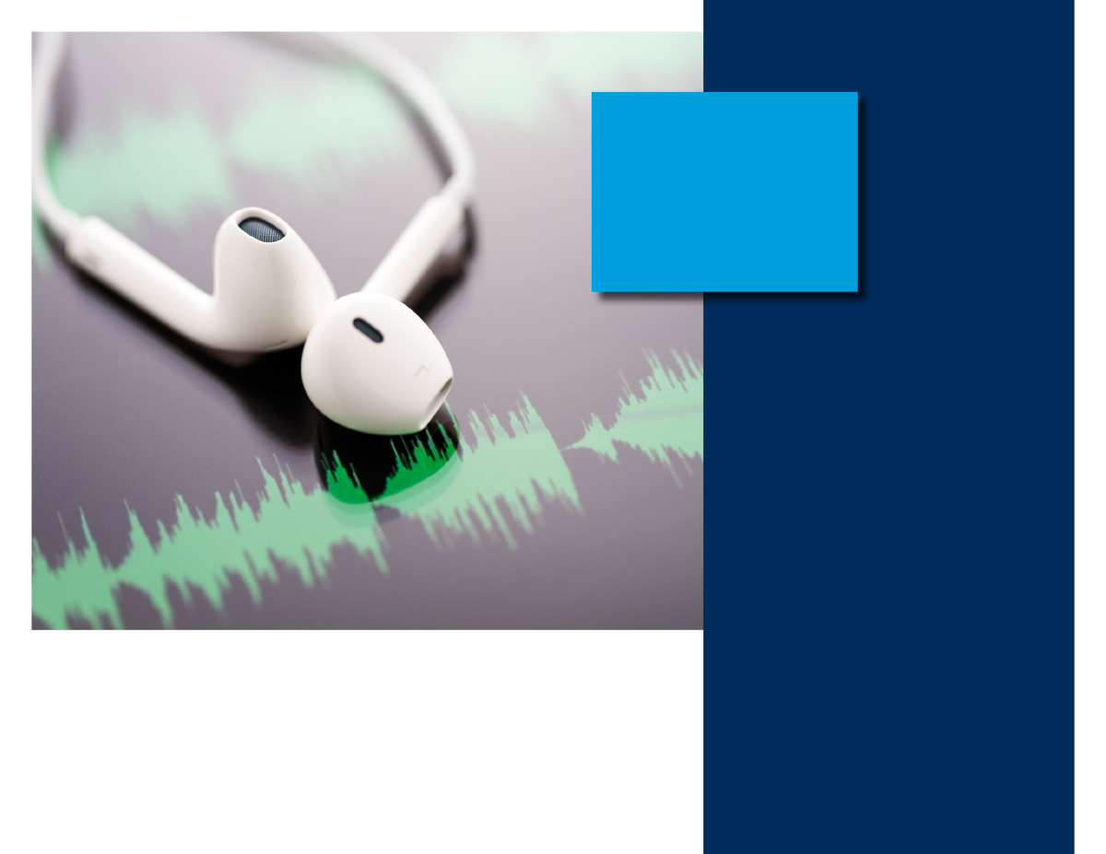

ONLINE SEMINAR

Conversation is a two-way activity, and listening is a very important part to ensure effective communication. This session will offer practical tips and discuss the benefits of being a good listener.

*(Typical seminar runtime: 20 minutes)*

YOUR EMPLOYEE ASSISTANCE PROGRAM

LET US HELP

Visit the Work/Life site starting Tuesday 5/16:

WEBSITE: [www.eap.wa.gov/worklife](http://www.eap.wa.gov/worklife)

YOUR ORG CODE (to logon): <ASD>

TOLL FREE: 1-877-313-4455

ALWAYS AVAILABLE | FREE | CONFIDENTIAL

The letters "eap" are below a radiating sun which contains a person with upraised arms

**Are You a Good Listener?**

**MAY 2023**